German business 德国企业

DAX max DAX指数新高

max v.达最大值；尽最大可能

A stockmarket milestone reflects **optimism** （for German companies）

股市里程碑折射出德国企业的乐观心态

1. stock-market [s'tɒk-mɑ:kɪt] n.证券市场；证券交易所；证券行情

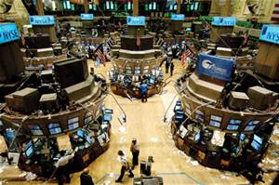

1. opti-mism [ˈɒptɪ-mɪ-zəm] n.乐观；乐观主义



ECONOMIC growth（n.） （of 2%) this year, as is expected in Germany, is **hot stuff** [only in the **context** of Europe's cool **climes**]. But the DAX index （of the country's biggest **listed companies**）is truly **sizzling**, closing above 10,000 points for the first time [on Monday June 9th], up by 22% **on** a year ago / and nearly **treble** the low （it hit in March 2009）.

德国今年的经济增长达到了预期的2%，这成绩只能在经济低迷的欧洲称得上醒目。不过该国最大的上市公司的DAX指数真可谓炙手可热，在6月9日收盘首次突破10,000点，比去年同比增长22%，几乎是2009年3月触底点数的三倍。

1. **hot stuff** [hɔt stʌf] n.<俚>“特殊材料制造的人”，**奇才，非凡的事物**

**N-UNCOUNT性感的人；激起情欲的事物**If you think that someone or something is hot stuff, you find them exciting or sexually attractive.

His love letters were **hot stuff**, apparently. 他的情书貌似写得**很火辣**。



1. **con-text** [ˈkɒn-tekst] **n.**上下文；**背景；环境；语境**

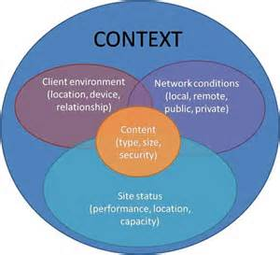

1. **clime** [klaɪm] n.气候，地方，地域。**气候带；气候区；（具有某种气候的）地区**
2. **listed company 股票上市的公司，上市公司**
3. **sizzle** ['sɪ-zl] **vi.** **（热油、脂肪等）发咝咝声；表现良好，进行顺利。**vt.把…烧得嘶嘶响；烧灼。n.油煎食物时)发出的咝咝声

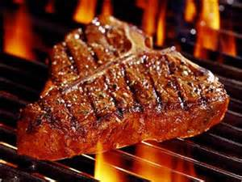

1. **above** [əˈbʌv] prep.（表示程度）**超过；（表示等级）在…之上；**（表示位置）在…正上方；（表示比较）优于。adv.在上面；以上；上述。n.上述。adj.上述的

————————————

•But the DAX index （of the country's biggest **listed companies**）is truly **sizzling**, closing above 10,000 points for the first time [on Monday June 9th], up by 22% **on** a year ago / and nearly **treble** the low （it hit in March 2009）.

1. **on ADV从…时候起；自…以后**You use on in expressions such as from now on and from then on to indicate that something starts to happen at the time mentioned and continues to happen afterwards.

Perhaps it would be best {not to see much of you [**from now on**]}... 也许**从现在起**我们最好少见面。

We can expect trouble **from this moment on**... **从此刻起**，我们将会麻烦缠身。

Morrison took the news badly / and [**from then on**] his spirits noticeably sagged. 这消息对莫里森打击很大，**从那以后**，他明显萎靡不振。

————————————

1. **tre-ble** ['tre-bl]  **adj.三倍的，**三重的；高音的；最高声部的；尖锐刺耳的。**vt.& vi.使成为三倍**；增加两倍。n.最高音部，高音；三倍。vi.变成三倍

2.**PREDET是…的三倍**If one thing is treble the size or amount of another thing, it is three times greater in size or amount.

More than 7 million shares changed hands, **treble** the normal daily average. 有 700 多万股换手，**是**通常日平均成交量**的 3 倍**。



The MDAX, an index of somewhat（adv.） smaller companies, has performed even better. **Share-traders**' **enthusiasm** is shared by bosses: the Ifo **business-climate index**, a widely watched **survey** of companies, shows an **optimism** （not seen since 2011）. What **justifies** the **cheer**?

小型公司的指数MDAX表现更为突出。公司经理们也被股东们的热情感染：本月，广受关注的企业调查IFO商业景气指数，显示了2011年以来难得的乐观情绪。为什么如此乐观？

1. **some-what** [ˈsʌm-wɒt] adv.稍微；有点；达到某种程度。n.少量；某些数量；某种程度

**ADV有点儿；有些；有几分**You use somewhat to indicate that something is the case to a limited extent or degree.

He concluded that Oswald was **somewhat abnormal**... 他断定奥斯瓦尔德**有点不正常**。

He explained **somewhat unconvincingly** {that the company was paying for everything}... 他解释说公司会支付一切费用，这个说法**有点令人不能信服**。

Although his relationship with his mother had **improved somewhat**, he was still depressed... 尽管和母亲的关系**有所改观**，他仍然十分消沉。

————————————

•**Share-traders**' **enthusiasm** is shared by bosses: the Ifo **business-climate index**, a widely watched **survey** of companies, shows an **optimism** （not seen since 2011）. What **justifies** the **cheer**?

1. **share trader股票投资者**
2. **en-thu-sia-sm** [ɪn-ˈθju:-ziæ-zəm] **n.热情，热忱；**热衷的事物；宗教的狂热



1. **business climate 商业气候，商业环境，商业景气**

**business climate index 企业景气指数**

1. **survey** ['sɜ:veɪ] vi.测量土地。**vt.调查；勘测；俯瞰。**n.调查（表），调查所，测量，测量部，测量图；概观，检查，鉴定书；环顾。**调查；民意调查；民意测验。总体研究；审视；全面观察**



1. optimism [ˈɒptɪmɪzəm] n.乐观；乐观主义
2. **justifies v.证明…有理**( justify的第三人称单数 )；为…辩护；对…作出解释；为…辩解（或辩护）
3. **cheer** [tʃiə] vt.欢呼；使高兴；为…喝彩；为…加油。**n.欢呼，喝彩**；兴致勃勃，愉快；心情；令人愉快的事。vi.欢呼；感到高兴

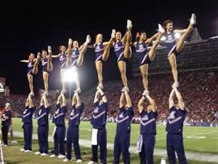

*Dirk Muller*, a trader and **commentator**, although **cautious（adj.） about** the heights share prices （are reaching）, thinks the **prospects** （for Germany's carmakers） are bright. Two of them, BMW and **Volkswagen**, have been among the top-five performers [over the past five years], and the DAX's best performer has been **Continental**, （a **car-parts** maker）.

交易员兼评论员德克穆勒，虽然对目前的高股价持谨慎态度，还是认为汽车制造商的前景一片光明。其中的宝马和大众汽车两家，在过去的五年都一直是前五名，而在DAX指数中表现最好的，是一家名为大陆的汽车零部件生产商。

1. **commen-tator** [ˈkɒmən-teɪ-tə(r)] **n.（电台的）时事评论员**，实况广播报导员；注解者，注释者；评论员，解说员；主持[解释]宗教仪式的非教士

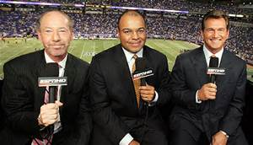

1. **cau-tious** [ˈkɔ:ʃəs] **adj.小心的，谨慎的**；兢；恮；持重

 

1. **pro-spect** ['prɒ-spekt] **n.前景；期望；眺望处；景象**。vi.勘探；勘察；（矿等）有希望；有前途。vt.找矿；对…进行仔细调查

**prospect作名词指“前景”时，常用复数形式。**

He has **good prospects**. 他**大有前途**。

**1.N-VAR可能性；希望I**f there is some prospect of something happening, there is a possibility that it will happen.

Unfortunately, there is little prospect of seeing these big questions answered... 不幸的是，几乎不可能看到这些重大问题得到回复。

The prospects for peace in the country's eight-year civil war are becoming brighter... 该国经历8年内战之后重归和平的前景正逐渐变得光明。

There is a real prospect that the bill will be defeated in parliament. 该议案很有可能会被议会否决。

**2.N-SING期望中的事；将要发生的事；预期；展望**A particular prospect is something that you expect or know is going to happen.

They now face the prospect of having to wear a cycling helmet by law... 他们现在面临的情形是：不久将需要依法佩戴摩托车头盔。

After supper he'd put his feet up and read. It was a pleasant prospect. 晚饭后，他会架起脚来看书。想起来就让人愉快。

**3.N-PLURAL（尤指事业的）成功机会，前景，前途**Someone's prospects are their chances of being successful, especially in their career.

I chose to work abroad 目的状to improve my **career** **prospects**. 我选择出国工作，以求在事业上有更好的发展。

...a detailed review （of **the company's prospects**）. 对**该公司前景**的详细考查

**4.VERB勘探；勘察**When people **prospect for** oil, gold, or some other valuable substance, they look for it in the ground or under the sea.

He had prospected for minerals everywhere from the Gobi Desert to the Transvaal... 他已在从戈壁沙漠到德兰士瓦的无数地方勘探过矿藏。

In fact, the oil companies are already prospecting not far from here. 事实上，石油公司已经在离此不远处进行勘探。

————————————

•Two of them, BMW and **Volkswagen**, have been among the top-five performers [over the past five years], and the DAX's best performer has been **Continental**, （a **car-parts** maker）.

1. BMW——Bayerische Motoren Werke 这是德语。巴伐利亚马达制造工场
2. Volks-wa-gen ['fɔ:lks-ˌvɑ:-gən] 德国大众汽车
3. **con-ti-nental** [ˌkɒn-tɪ-'nentl] **adj.大陆的，大陆性的**，欧洲大陆的；〈美〉（独立战争时）美洲殖民地的。n.欧洲大陆人；〈美〉（独立战争中的）美国兵[纸币]；〈美俚〉（起源于英国的）欧洲大陆发式

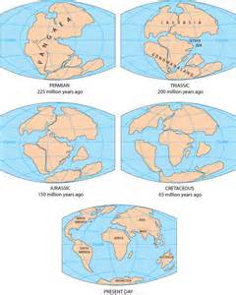

1. **car parts 汽车零件**

[In recent years] the **run-up** in （German automotive and engineering firms）' shares has been driven by **booming emerging-market** sales. Now, China's market is cooling, and the prospects （for sales in Russia） have been **dampened** by its **confrontation（n.）** with the West over Ukraine.

最近几年，拜新兴市场蓬勃发展的销售所赐，德国汽车和工程公司的股票大幅增长。

现在，中国市场正在降温，而俄罗斯和西方在乌克兰问题上的对抗，使得该国的销售前景黯淡无光。

1. **run-up n.抬高；将引擎加速，起转；<英>事件的前奏曲，预备阶段；助跑**

————————————

1. **boom-ing** ['bu:-mɪŋ] **adj.急速发展的。**v.激增( boom的现在分词 )；猛涨；发出隆隆声；以低沉有力的声音说话

boom是象声动词,**基本意思是“隆隆作响”,常用于其引申意“繁荣”“激增”“迅速发展”。**

**1.N-COUNT（经济的）繁荣，景气**If there is a boom in the economy, there is an increase in economic activity, for example in the amount of things that are being bought and sold.

An economic boom followed, especially in housing and construction... 接着出现了经济繁荣，尤其是在房地产业和建筑业。

The 1980s were indeed boom years. 20世纪80年代是真正的繁荣时期。

...the cycle of boom and bust which has damaged us for 40 years. 40年来给我们造成巨大破坏的经济繁荣与萧条的交替循环

**2.N-COUNT（数量的）增长；（频率的）加快；成功**A boom in something is an increase in its amount, frequency, or success.

**The boom（n.）** （in the sport's popularity） / has meant more calls （for stricter safety regulations）... 该项体育运动的兴起，意味着制定更加严格的安全规则的呼声更高了。

Public transport has not been able to cope adequately with the travel boom. 公共交通系统，还不能充分满足迅速发展的旅游业的需求。

**3.VERB（经济或生意）景气，繁荣**If the economy or a business is booming, the amount of things being bought or sold is increasing.

[By 1988] the economy was **booming**... 到1988年经济一直**很繁荣**。

Sales are **booming**... 销售额在**快速增长**。

It has a **booming（v.）** tourist industry. 其旅游产业在**蓬勃发展**。

————————————

•[In recent years] the **run-up** in （German automotive and engineering firms）' shares has been driven by **booming emerging-market** sales. Now, China's market is cooling, and the prospects （for sales in Russia） have been **dampened** by its **confrontation（n.）** with the West over Ukraine.

1. e-merge [ɪ-'mɜ:dʒ] vi.出现，浮现；暴露；摆脱

**emerging adj.（用作定语）新兴的。**v.出现( emerge的现在分词 )；露头；形成；事实

**emerging market 新兴市场**

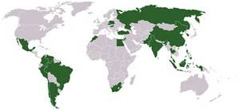

1. dam-pen ['dæm-pən] vt.抑制；使潮湿；使…沮丧；隔音，防音。vi.变得潮湿；丧气

**1.VERB降低，减弱，抑制（热情、激动等）**To dampen something such as someone's enthusiasm or excitement means to make it less lively or intense.

Nothing seems to **dampen his** perpetual **enthusiasm**... 似乎没有什么能让他那持久的**热情消退**。

**I hate to dampen your spirits /** but aren't you overlooking a couple of minor points. **我不想扫你的兴**，但你是否忽视了几个小的问题呢？

To **dampen** something **down** means the same as to **dampen** it.

Although unemployment rose last month, this is unlikely to dampen down wage demands...

虽然上个月失业人数上升，但这不太可能减弱工人要求加薪的意愿。

The economy overheated and the Government used interest rates to dampen it down.

经济发展过热，政府通过利率加以抑制。

**2.VERB使潮湿；弄湿**If you dampen something, you make it slightly wet.

She took the time to dampen a washcloth and do her face. 她花了点时间弄湿毛巾，洗了把脸。

————————————

•Now, China's market is cooling, and the prospects （for sales in Russia） have been **dampened** by its **confrontation（n.）** with the West over Ukraine.

1. **con-fron-tation** [ˌkɒn-frʌn-ˈteɪʃn] **n.对抗；面对；遭遇；对峙**

**1.N-VAR对抗；冲突；战斗；战役**A confrontation is a dispute, fight, or battle between two groups of people.

The issue has caused great tension between the two countries / and could lead to **a military confrontation**... 这个问题使得两国关系非常紧张，可能会导致**军事对抗**。

The commission remains so weak that it will continue to **avoid confrontation** **with** governments. 该委员会的力量仍然十分薄弱，所以将继续**避免与**各国政府**发生冲突**。

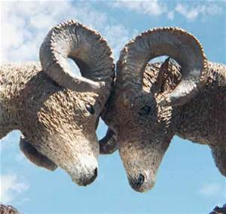

1. **U-kraine** [ju:-'kreɪn] **n.（国名）乌克兰**

However, markets （closer to home） are coming to the rescue: car sales in Europe have increased for eight months **in a row**. Volkswagen, which sold 4.4% more cars [in the first five months of 2014] than in the same period （last year）, says western Europe is now only second to the Asia-Pacific region in sales growth, a big change [from recent years].

不过，窝边草成了救命草：连续八个月，欧洲汽车销售量节节攀升。大众汽车在头五个月的销售量，比去年同期增长了4.4%。它表示，西欧市场的销售增长目前仅次于亚太地区，这同前几年相比可是大大不同了。

1. **in a row**  成一行；一字儿；接连；一连。**连续 一直，连续不断地**

That was the fifth quarter **in a row** that number has dropped. 这是该数字连续第五个季度下降。（**quarter** ['kwɔ:tə(r)] n.四分之一；一刻钟；地区；（美式足球的）一节。**季度；季。**vt.把…四等分；供…住宿；使（士兵）驻扎）

Other German businesses may **likewise（adv.）** see **renewed vigour** in domestic, European and rich-world markets, **compensating（v.）** **for** the weakening **outlook** （elsewhere）. Barclays, （同位a bank）, thinks that a **long-overdue** recovery （in **capital spending** by companies （indeveloped economies））, should help the country's many **makers** （of industrial equipment and services）.

其他的德国企业，可能也同样发觉了重新焕发活力的德国、欧洲和富裕国家市场，从而对于弱化的其他市场有所补偿。巴克莱银行认为，正如人们期待已久的，发达国家的资本支出开始回升，给德国的工业设备制造商、和服务提供商的发展，提供了助力。

1. **like-wise** [ˈlaɪk-waɪz]  **adv.同样地；也，而且**

**1.ADV同样地；类似地**You use likewise when you are comparing two methods, states, or situations and saying that they are similar.

These requests are ignored. His requests for rent are likewise sometimes ignored... 这些要求被置之不理。他关于支付租金的要求有时也同样未被理睬。

The V2 was not an ordinary weapon: it could only be used against cities. Likewise the atom bomb.

V2火箭并非普通武器：它只能用于对付城市。原子弹也是这样。

**2.ADV照样地**If you do something and someone else does likewise, they do the same or a similar thing.

He lent money, made donations and encouraged others to do likewise. 他又借钱又捐款捐物，并且鼓励别人也这样做。

————————————

•Other German businesses may **likewise（adv.）** see **renewed vigour** in domestic, European and rich-world markets, **compensating（v.）** **for** the weakening **outlook** （elsewhere）.

1. **re-new-ed** **adj.更新的；重建的；复兴的**；重申的。v.（使）复原， （使）更新，赋予新的生命和活力( renew的过去式和过去分词 )；重新开始；继续；补充
2. **vi-gour** [ˈvɪ-gə(r)] **n.精力，活力；气势**；强健；**有力行动**。vigor的变体

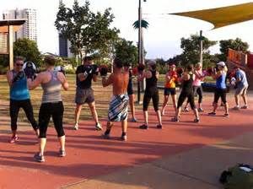

1. **com-pen-sate** ['kɒm-pen-seɪt] **vt.补偿，赔偿；**报酬；抵消。vi.补偿，**弥补**

**1.VERB赔偿；补偿**To **compensate** someone **for** money or things that they have lost means to pay them money or give them something to replace that money or those things.

The official promise （to **compensate** people **for** the price rise clearly） hadn't been worked out properly... 显然，官方对物价上涨进行补偿的承诺，没有真正兑现。

To ease financial difficulties, farmers could be compensated for their loss of subsidies. 为了缓解经济困难，农场主们损失的补贴会得到补偿。



**2.VERB弥补；补偿**If you **compensate for** a lack of something or **for** something you have done wrong, you do something to make the situation better.

The company agreed to keep up high levels of output in order to compensate for supplies lost... 这家公司同意保持高产量以弥补供货丢失带来的缺口。

She would then feel guilt for her anger and compensate by doing even more for the children. 之后她会因为自己发火而感到愧疚，会替孩子们做更多的事作为补偿。

**3.VERB抵消**Something that **compensates for** something else balances it or reduces its effects.

MPs say it is crucial that a system is found to compensate for inflation... 下议院的议员们说关键是要找到一种抵消通货膨胀影响的机制。

The pluses more than compensated for the inconveniences involved in making the trip. 各种有利因素大大抵消了出行过程中的种种不便。

**4.VERB弥补（过失或不足）**If you try to **compensate for** something that is wrong or missing in your life, you try to do something that removes or reduces the harmful effects.

People who sense that they are inferior have to compensate, and often over-compensate by way of outward achievement. 觉得自卑的人只有通过外在的成就来弥补自己的不足，但往往都做过了头。

No supportive words could ever compensate for the pain of being separated from her children for 10 years. 任何表示支持的言语都无法弥补与孩子们分开10年带给她的痛苦。

————————————

•Other German businesses may **likewise（adv.）** see **renewed vigour** in domestic, European and rich-world markets, **compensating（v.）** **for** the weakening **outlook** （elsewhere）.

1. **out-look** ['aʊt-lʊk] **n.前景，展望**；观点，见解；景色；眺望处。v.瞪着看，瞧；比…漂亮；用目光压倒

**1.N-COUNT世界观；人生观；（对生活的）观点，看法**Your outlook is your general attitude towards life.

The illness had a profound effect on his outlook... 这场病对他的人生观产生了深刻的影响。

I adopted a positive outlook on life... 我开始抱持积极向上的人生观。

We were quite different in outlook, Philip and I. 我和菲利普的世界观截然不同。

**2.N-SING展望；前景；可能性**The outlook for something is what people think will happen in relation to it.

The economic outlook is one of rising unemployment... 展望未来的经济，失业率将会上升。

Has motherhood changed your career outlook? 当了母亲是否改变了你的职业前途？

...the uncertain outlook for the motor industry. 汽车工业的不明朗前景

————————————

•Barclays, （同位a bank）, thinks that a **long-overdue** recovery （in **capital spending** by companies （indeveloped economies））, should help the country's many **makers** （of industrial equipment and services）.

1. **over-due** [ˌəuvə-ˈdju:] adj.过期的；延误的，迟到的；未兑的；早应完成的

**1.ADJ-GRADED（变化或事件）早该发生的**If you say that a change or an event is overdue, you mean that you think it should have happened before now.

This debate is **long overdue**... 这场辩论**早该进行了**。

I'll go home / and **pay an overdue visit** （to my mother）. 我将回家看望母亲，其实我**早该回去了**。



**2.ADJ-GRADED（钱款）到期未付的，拖欠的**Overdue sums of money have not been paid, even though it is later than the date on which they should have been paid.

Teachers have joined a strike aimed at forcing the government to pay overdue salaries and allowances. 教师加入了旨在迫使政府支付拖欠薪水和津贴的罢工。

**3.ADJ-GRADED（图书馆的书）逾期未还的**An overdue library book has not been returned to the library, even though the date on which it should have been returned has passed.

————————————

1. **long-overdue 期待已久的**
2. **capital spending 资本支出，资本投资**

**capital N-UNCOUNT资本；资金**Capital is a large sum of money which you use to start a business, or which you invest in order to make more money.

1. **developed economies 发达经济体**
2. makers N-COUNT生产商；制造商

As examples, Barclays mentions *Siemens*, （an **engineering conglomerate**）, *Infineon*, （a microchip-maker）, and *SAP*, （which makes business software）. All three have struck **cheerier** notes [in recent results announcements].

巴克莱银行提到的例子，包括工程集团西门子，微芯片制造商英飞凌，还有商业软件制造商SAP。以上三家公司都在最近的业绩公告中有好消息。

1. Sie-mens [ˈsi:-mənz] 西门子(MKS 制电导单位，相当于欧姆)
2. **con-glo-me-rate** [kən-'ɡlɒ-mə-rət] **n.** **大型联合企业；企业集团。联合大企业**；砾岩；合成物；组合物。adj.成团的；砾岩性的。**vt.使聚结；使成团**

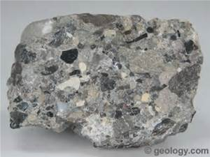

1. **engineering conglomerate 工程集团，工程巨鳄**

————————————

1. strike [straɪk] v.，n. ①罢（工、课等）；②撞；打；击。攻击；撞击；碰撞。（军事）打击，攻击；（尤指）空袭。③（疾病、灾难等）侵袭，爆发。来到

**11.VERB给…印象；让…觉得**If something **strikes** you **as** being a particular thing, it gives you the impression of being that thing.

He struck me as a very serious but friendly person... 他让我感觉他是一个十分严肃但友好的人。

What struck me as interesting is how much we judge other people by the clothes they wear... 让我觉得很有意思的是我们经常以衣取人。

You've always struck me as being an angry man. 我感觉你好像总是一副气冲冲的样子。

**12.VERB打动；把…迷住**If you **are struck** by something, you think it is very impressive, noticeable, or interesting.

She was struck by his simple, spellbinding eloquence... 她被他那率直、富有鼓动性的口才迷住了。

Theresa was struck by her own lack of forethought... 特蕾莎强烈意识到自己事先太欠考虑了。

What struck me about the firm is how genuinely friendly and informal it is. 该公司的真诚、友好和不拘小节深深打动了我。

**13.V-RECIP达成（交易或协议）**If you strike a deal or a bargain with someone, you come to an agreement with them.

They **struck a deal with** their paper supplier, getting two years of newsprint on credit... 他们**同**纸张供应商**达成协议**，可赊购两年的新闻用纸。

The two **struck a deal** （in which Rendell took half of what a manager would）... 两个人**达成协议**，伦德尔获得相当于经理所得的一半。

He insists {he has **struck** no **bargains** for their release}. 他坚称，他没有就他们的获释**达成**过任何**交易**。

**14.VERB达到（两全其美）；找到（折中的办法）**If you strike a balance, you do something that is halfway between two extremes.

[At times like that] you have to **strike a balance between** sleep **and** homework. 在这种情形下，你得**在**休息**和**做作业**之间找到一种平衡**。

**15.VERB摆出（姿态）；表现出（态度）**If you strike a pose or attitude, you put yourself in a particular position, for example when someone is taking your photograph.

She **struck a pose**, one hand on her hip / and the other waving an imaginary cigarette. 她**摆了个姿势**，一只手叉腰，另一只手夹着一支假想的香烟。

**16.VERB使感到（恐惧或惊慌）**If something **strikes** fear **into** people, it makes them very frightened or anxious.

If there is a single subject guaranteed {to **strike fear** in the hearts （of parents）}, it is drugs. 如果只有一样东西定能**让**父母**感到恐惧**，那就是毒品。（**gua-ran-tee** [ˌɡæ-rən-'ti:] n.保证，担保；保证人，保证书；抵押品。**vt.**保证，担保。**确保；使必然发生**）

**17.VERB使顿时（看不见或说不出）**If you **are struck** dumb or blind, you suddenly become unable to speak or to see.

I **was struck dumb** by this / and had to think it over for a moment... 这让我**吃惊得说不出话来**，我不得不仔细考虑一会儿。

[For this revelation] he **was struck blind** by the goddess Hera. 由于揭露此事，他**被**女神赫拉**弄瞎了眼**。

**25.PHRASE近在咫尺**If you are **within striking distance of** something, or if something is **within striking distance**, it is quite near, so it could be reached or achieved quite easily.

I believe we are **within striking distance of** an agreement... 我相信我们**即将达成**协议。

The airport was **within striking distance**: no more than sixty miles to the west. 机场**近在咫尺**，西行不到 60 英里即到。

**26.PHRASE打开成功（或财富）之门；踏上通往成功（或财富）之路**If you **strike gold**, you find, do, or produce something that brings you a lot of money or success.

The company has **struck gold** [方式状with its new holiday development, Center Parcs]. 该公司凭借其新开发的“中央公园”度假村，而**赚了个盆满钵满**。

**27.PHRASE（尤指）暴富；发大财**If you **strike it rich**, you make a lot of money, especially in a short time.

He hoped to **strike it rich** by investing in ginseng. 他希望通过投资人参**发大财**。

————————————

•All three have struck **cheerier** notes [in recent results announcements].

1. **cheery** ['tʃɪə-rɪ] **adj.喜气洋洋的，兴高采烈的，**欢乐的；愉快的；高兴的；快活的

**ADJ-GRADED（人、行为）愉快的，欢快的**If you describe a person or their behaviour as cheery, you mean that they are cheerful and happy.

She was **cheery（adj.）** and talked to them about their problems. 她兴致很高，和他们谈了他们的难题。

cheerily

'Come on in,' she **said cheerily**. “进来，”她**兴高采烈地说**。

 

1. **result announcement业绩公布，结果公告**

Growth in company profits tends to lag GDP growth by a couple of quarters, so Siemens expects the strong first-quarter economic figure 宾补to translate into higher sales [later this year]. SAP sees {the packaged-software **market（n.）** in its Europe, Middle East and Africa region growing by more than 5% [this year]}.

公司的利润增长通常会落后于GDP增长几个季度，因此西门子预计，第一季度的经济数据势头强劲，将会在今年晚些时候转化为销售额的增长。SAP预计今年其套装软件在欧洲、中东及非洲地区的销量增幅，将超过5%。

1. translate的基本意思是“翻译”,常指把一种语言译成另一种语言。引申可作“转化”“解释”解。

translate也可作“调动”解,通常指某人调到另一地方。

**translate后接介词into表示“把…翻译成…”“把…转化为…”**； 后接介词短语from...into...表示“(把…)从…翻译成为…”； 后接介词to表示“调某人到…”。

**3.V-ERG（使）转变为；（使）转化为**If one thing **translates** or is **translated into** another, the second happens or is done as a result of the first.

Reforming Warsaw's stagnant economy requires harsh measures that would translate into job losses... 重整华沙停滞的经济需要强硬措施，这会造成工作岗位的裁减。

Your decision must be translated into specific, concrete actions. 你的决定必须转化为具体明确的行动。

————————————

1. **market N-SING（尤用于谈论同行业竞争时）年销售量，市场总额**The market refers to the total amount of a product that is sold each year, especially when you are talking about the competition between the companies who sell that product.

The two big companies control 72% of the **market**. 两大公司控制了72%的**市场份额**。

*Infineon* expects **revenue** growth （of between 4% and 8%） in the current quarter, and thinks rising demand （from carmakers and other industrial customers） will drive its growth this year. Although bosses are sounding increasingly happy about the prospects for their businesses, economists are **wary**.

英飞凌预计，本季度的收入增长将介于4%和8%之间，并且随着汽车制造商和其他工业客户的需求增长，它的增长也会被相应推动。尽管企业经营者们对于商业前景愈来愈欢欣鼓舞，经济学家们却忧心忡忡。

1. **reve-nue** ['revə-nju:] **n. （公司、组织的）收入，收益；**（政府的）财政收入，税收。（国家的）岁入，税收，（土地，财产等的）收入，收益，所得，（个人的）固定收入；[复数]总收入；税务署，〈美俚〉税务官；税务局



1. **wa-ry** ['weə-rɪ] **adj.谨慎的，小心翼翼的；警戒的，警惕的**

**1.ADJ-GRADED小心的；提防的**If you are **wary of** something or someone, you are cautious because you do not know much about them and you believe they may be dangerous or cause problems.

People did not teach their children 宾补to be **wary of** strangers... 过去人们不会教育孩子**提防**陌生人。

They were **very wary** about giving him a contract. 他们跟他签合同时**非常谨慎**。

warily

She studied me warily, as if I might turn violent. 她**警惕地**看着我，似乎担心我会动粗。

**2.PHRASE小心观察；警惕察看**If you keep **a wary eye** on something or someone, you are cautious about them and watch them to see what they will do or what will happen to them.

Bankers are **keeping a wary eye** on the outcome. 银行家们**对**结果**保持高度警惕**。

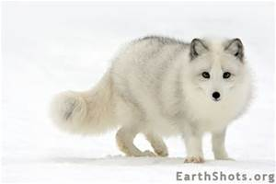

They think the **hype（n.）** （on the stockmarket ）may be **excessive（adj.）**. **In particular**, they worry {that the decision （on June 5th） （by the European Central Bank） （to push interest rates downinto **uncharted territory**） risks inflating（v.） a bubble}, it was surely no coincidence {that the DAX's **record high** came [so soon] [after the ECB's decision]}.

他们特别担心欧洲央行在6月5日决定将利率压低到前所未有的程度，这将催生泡沫—之后，DAX指数很快创下历史新高，这绝非巧合。

1. **hype** [haɪp] **n.天花乱坠的广告宣传。vt.大肆宣传；夸张地宣传（某人或某事物）**



1. **ex-ces-sive** [ɪkˈse-sɪv] **adj.过度的，极度的；过分的**；过多的；过逾

**1.ADJ-GRADED过分的；过多的**If you describe the amount or level of something as excessive, you disapprove of it because it is more or higher than is necessary or reasonable.

...the alleged use of excessive force by police... 警察涉嫌滥用武力

The government says that local authority spending is excessive. 政府称地方当局开支过大。

excessively

Managers are also accused of paying themselves excessively high salaries... 经理们还被指责给自己支付过高的薪水。

Mum had started taking pills and drinking excessively. 妈妈开始服药酗酒。

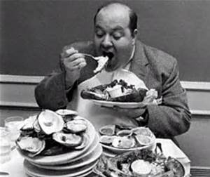

•**In particular**, they worry {that the decision （on June 5th） （by the European Central Bank） （to push interest rates downinto **uncharted territory**） risks inflating（v.） a bubble}, it was surely no coincidence {that the DAX's **record high** came [so soon] [after the ECB's decision]}.

1. par-ti-cular [pə-ˈtɪ-kjə-lə(r)] adj.特别的；详细的；独有的；挑剔的。n.特色，特点；（可分类，列举的）项目；详细情节，细情，细目；某一事项

**In particular尤其， 特别**

————————————

1. **un-charted** [ˌʌn-ˈtʃɑ:-tɪd] **adj.未知的，图上未标明的**

**1.ADJ陌生的；不熟悉的**If you describe a situation, experience, or activity as uncharted territory or waters, you mean that it is new or unfamiliar.

Carter's fourth album [definitely] **moves into uncharted territory**. 卡特的第四张专辑，无疑**涉足了全新的领域**。（①defi-nitely [ˈdefɪ-nətli] adv.明确地；确切地；一定地；肯定地。int.（表强烈的肯定）当然。 ②terri-tory ['terə-trɪ] n.领土，版图；领地；领域，范围；[商]势力范围）

...**a largely uncharted area** of medical science. 医学中**一个几乎全新的领域**（largely ADV-GRADED大致上；总体上；一般地说。（用于说明原因）主要地）



•**In particular**, they worry {that the decision （on June 5th） （by the European Central Bank） （to push interest rates downinto **uncharted territory**） risks inflating（v.） a bubble}, it was surely no coincidence {that the DAX's **record high** came [so soon] [after the ECB's decision]}.

1. **ter-ri-tory** ['terə-trɪ] **n.领土，版图；领地；领域，范围**；[商]势力范围

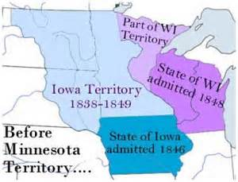

1. **uncharted territory未知领域**
2. **risk** n.危险，冒险；保险额；被保险人或物**。vt.冒…的危险；使…冒风险（或面临危险）**
3. **inflating** [ɪn-'fleɪ-tɪŋ] v.使充气（于轮胎、气球等）( inflate的现在分词 )；（使）膨胀；**（使）通货膨胀；物价上涨**

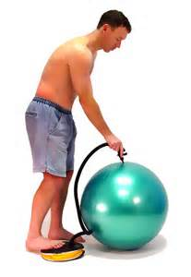

1. **bub-ble** ['bʌ-bl] **n.泡，水泡；冒泡，起泡**；泡影，妄想；（欲表达的）一点感情。vt.& vi.起泡，使冒气泡。vi.使冒泡，发出冒泡的声音；洋溢着（某种感情）；滔滔不绝地讲；兴奋，欢闹



1. **inflating（v.） a bubble 引发一场泡沫，催生泡沫**
2. coin-ci-dence [kəʊˈɪn-sɪ-dəns] n.巧合；一致；同时存在；并存

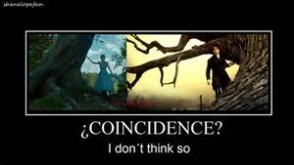

1. **record high [经] 破纪录的高点**

Exactly a year ago today, wall street **hit a record high**. 一年前的10月9日，华尔街股市**触及创纪录的高点**。

1. ECB: European Central Bank欧洲中央银行

But the industrial bosses see a positive side [to the ECB's move]: cutting interest rates should tend to weaken the **euro**, making their exports （outside the **currency** zone） 宾补more competitive / and **boosting** their value [when translated back into euros].

不过，产业经营者们却看到了欧洲央行举动的积极一面：降息将削弱欧元，增加他们在欧元区外的出口竞争力，并在折算回欧元的时候提高他们的价值。

1. **euro** ['jʊə-rəʊ] **n. 欧元**

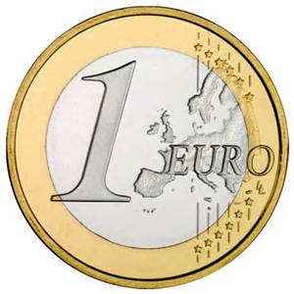

1. **cur-rency** ['kʌ-rənsɪ] **n.** **通货，货币；**通用，流通，流传，传播；市价，行情；流通时间

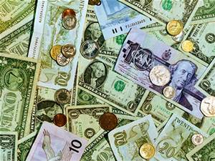

1. **the currency zone 货币区**
2. **boost** [bu:st] **vt.促进，提高；增加；**吹捧；向上推起。vi.宣扬；[美国俚语]（尤指在商店）行窃，偷窃。n.提高，增加；帮助；吹捧；加速[助推]器

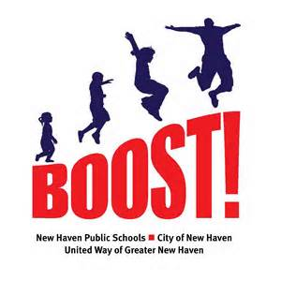

Adidas, （a **sportswear**-maker）, says that the **strengthening** euro **knocked** a 235m **dent** in its sales last year. Furthermore, with interest rates so low, German banks are **falling over** themselves 目的状to tempt customers [with **loans]**, to buy new **kitchens** / and take dream holidays, while同时 loosening their loan **criteria**.

阿迪达斯运动服的制造商表示，去年欧元升值导致销售量下降了2.35亿欧元。此外，德国银行借低利率之机，千方百计的吸引客户贷款购买新厨房、或者实现自己的梦想假期，同时还降低了贷款标准。

1. **sports-wear** [ˈspɔ:tsˌweə, ˈspəʊrts-] **n.运动装，休闲活动穿着的衣服**
2. **streng-then** ['streŋ-θn] **vt.加强，巩固；**勉励，激励；增加…的艺术效果；**（价格）上涨。vi.变强；变坚挺**

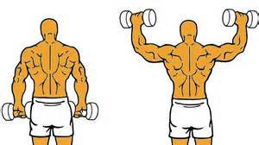

1. **knock** **N-COUNT打击**If someone receives a knock, they have an unpleasant experience which prevents them from achieving something or which causes them to change their attitudes or plans.

What they said was **a real knock** to my self-confidence... 他们的话是对我自信心的**一次重大打击**。

The art market has **suffered some severe knocks** during the past two years. 在过去的两年间，艺术品市场**遭受了严重的打击**。

————————————

•Adidas, （a **sportswear**-maker）, says that the **strengthening** euro **knocked** a 235m **dent** in its sales last year.

1. **dent** [dent] **n.凹痕，凹部**；齿；**减少，削弱**；[名]登特。vt.使产生凹痕；削弱；打击，破坏；产生不好的影响。vi.出现凹痕；产生凹陷；凹进去；削减

**1.VERB使凹陷；使产生凹痕**If you dent the surface of something, you make a hollow area in it by hitting or pressing it.

A great chunk of loose kerbing smashed into my left-front wheel, bursting the tyre and denting the rim... 我车子的左前轮撞在一大块松动的路缘石上，导致车胎爆裂、轮辋凹陷。

Its brass feet dented the carpet's thick pile. 其黄铜支脚把厚绒地毯压出了印。

dented

Watch out for bargains, but never buy dented cans. 留意便宜货，但绝不要买表面凹陷的罐头。

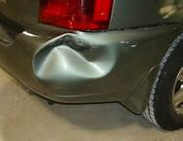

**2.N-COUNT凹痕；凹坑**A dent is a hollow in the surface of something which has been caused by hitting or pressing it.

There was a dent in the car which hadn't been there before. 车上出现了一处以前没有的凹痕。

**3.VERB削减；削弱；损害**If something dents your ideas or your pride, it makes you realize that your ideas are wrong, or that you are not as good or successful as you thought.

This has not **dented** **the** City's **enthusiasm** （for the company）. 这并没有**减弱**伦敦金融界对这个公司的**热情**。

[After a while] that sort of thing **dents your confidence**. 那种事情过上一段时间就会**挫伤信心**。

**4.N-COUNT削减；削弱**If one thing makes a dent in another, it reduces it by a large amount.

The commission had barely begun to **make a dent in the problem**... 委员会几乎还没有**在这个问题上取得**任何**进展**。

I hated to **put** any **dents in his enthusiasm**, but I was trying to be realistic（adj.）. 我不想**打击他的热情**，只是试图现实一些。（rea-lis-tic [ˌri:ə-ˈlɪs-tɪk] adj.现实的；[艺] 现实主义的，[哲]实在论（者）的；逼真的；栩栩如生的）

————————————

•Furthermore, with interest rates so low, German banks are **falling over** themselves 目的状to tempt customers [with **loans]**, to buy new **kitchens** / and take dream holidays, while同时 loosening their loan **criteria**.

1. **fall over** 被…绊倒。摔倒；跌倒；倒下；意外地从…上跌落；**落在…之外；迫不及待做某事**

————————————

1. **loan** [ləʊn] **n.贷款；借款**；借用。vt.借，借给。vi.借出

loan可用作及物动词,意为“借,借出”。美式英语中常用lend代替loan。而这种用法在英式英语中则较少见,英国人通常用loan表示“正式地长期出借”。

**1.N-COUNTSee also:bridging loan；soft loan；贷款；借款**A loan is a sum of money that you borrow.

The country has no access to foreign loans or financial aid... 该国得不到任何外国贷款或经济援助。

The president wants to make it easier for small businesses to get bank loans. 总统希望能让小企业更方便地获得银行贷款。

...loan repayments. 清偿贷款的分期付还款项

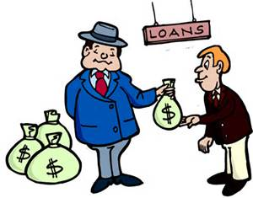

**2.N-SING暂借**If someone gives you a **loan of** something, you borrow it from them.

I am in need of a loan of a bike for a few weeks... 我需要借辆自行车用几个星期。

He had offered the loan of his small villa at Cap Ferrat. 他愿意借出在费拉角的小别墅。

**3.VERB借出**If you loan something to someone, you lend it to them.

He had kindly offered to loan us all the plants required for the exhibit... 他善解人意地提出愿意把展览需要的植物通通借给我们。

We were approached by the Royal Yachting Association to see if we would loan our boat to them. 皇家游艇协会的人找过我们，问我们能不能把船借给他们。

Loan out means the same as loan .**loan out同loan**

It is common practice for clubs to loan out players to sides in the lower divisions...

俱乐部把球员外借给下级联赛中的球队是常例。

The ground was loaned out for numerous events including pop concerts.

场地被借用来搞过无数活动，包括流行音乐会。

**4.PHRASE借用中；借出中**If something is **on loan**, it has been borrowed.

...impressionist paintings on loan from the National Gallery... 从国家美术馆借出的印象派画作

Many of these are on display in the Museum, but some have been sent out on loan to other museums. 其中很多在博物馆展出，但也有一些借给了其他博物馆。

**5.PHRASE借调；商借**If a person is **on loan** from one organization to another, they are temporarily working for the second organization while still employed by the first.

David Speedie, on loan from Southampton, scored his first goal for Birmingham... 从南安普敦转借来的戴维·斯皮迪为伯明翰进了他的第一球。

She's on loan to us from the CIA. 她是从中央情报局借调给我们的。

**loan, lease, lend 这组词都有“借出”的意思。其区别是：**

lend 是最普通的用语,

**loan 指“贷与”“借与”,是财会上的正式用语,一般不用于私人关系的借贷,**但在美式英语中, loan 和lend两个词通用；

lease一般指出租房屋、土地等不动产。

**lend borrow loan 这些动词均含“借”之意**

lend指将自己的东西借出给别人，也可用于借喻意义。

borrow指从某人或某处借来某物，也可用作比喻。

**loan指通过正式的手续，借数目较大的贷款。**在美国也可指借出东西。

————————————

•Furthermore, with interest rates so low, German banks are **falling over** themselves 目的状to tempt customers [with **loans]**, to buy new **kitchens** / and take dream holidays, while同时 loosening their loan **criteria**.

1. kit-chen ['kɪ-tʃɪn] n.厨房；厨师

————————————

1. **cri-te-ria** [kraɪ-'tɪə-rɪə] **n.（批评、判断等的）标准，准则**( criterion的名词复数 )；(criterion的复数)

**cri-te-rion** [kraɪ-'tɪə-rɪən] n.（批评、判断等的）标准，准则；规范

**N-COUNT（判定的）标准，准则**A criterion is a factor on which you judge or decide something.

The most important **criterion** for entry is that applicants must design and make their own work... 最重要的参赛**标准**是，申请者必须设计并制作自己的作品。

British defence policy had to meet **three criteria** / if it was to succeed. 要想奏效，英国的国防政策必须具备**3个条件**。



Although **retailers** are not yet as cheerful as manufacturers, their **spirits** will be raised, if the German **Chambers** （of **Commerce（n.）** and Industry） is correct in foreseeing a strong **revival（n.）** in **domestic consumption（n.）**.

虽然零售商没有像制造商那么欢天喜地，但如果德国工商会对于国内消费将强劲复苏的预言成真，那么这些零售商们也可以大舒一口气了。

1. **re-tailer** [ˈri:-teɪ-lə(r)] **n.零售商，零售店**；传播的人，处散布闲话的人



1. **spirits** ['spɪrɪ-ts] **n.情绪；兴致；**精灵；灵魂；精神( spirit的名词复数 )；情绪；灵魂；神灵

**spirit作“情绪,心情”解时,多用于复数形式； 作“含酒精多的酒”解时,也多用于复数形式。**



1. **cham-ber** ['tʃeɪm-bə(r)] n.室，卧室，**会客室；内庭。议会；议院**；**[多用于英国]律师的办公室；议事厅。**vt.限制，幽禁，封闭或限制；使备有房间
2. **com-mer-ce** ['kɒmɜ:s] **n.商业；商务；贸易**

They have made their fortunes from **industry and commerce**. 他们靠**工商业**发了财。



•Although **retailers** are not yet as cheerful as manufacturers, their **spirits** will be raised, if the German **Chambers** （of **Commerce（n.）** and Industry） is correct in foreseeing a strong **revival（n.）** in **domestic consumption（n.）**

1. **re-vi-val** [rɪ-ˈvaɪ-vəl] **n.复活**；再生，再流行，**再生效；复兴**；（老戏多年后）重新上演

**1.N-COUNT复苏；复兴；恢复；再次流行**When there is a **revival of** something, it becomes active or popular again.

This return to realism has produced a **revival** （of interest） in a number of artists... 这种重回现实主义的趋势，已经重新激起了人们对许多艺术家的兴趣。

There is little chance of a **revival** （n.）in new car sales / until at least August next year. 至少到明年8月之前，新车销量回升的希望都微乎其微。

**2.N-COUNT（戏剧、歌剧或芭蕾等的）重新上演**A revival is a new production of a play, an opera, or a ballet.

...John Clement's revival of Chekhov's 'The Seagull'. 约翰·克莱门特对于契诃夫的《海鸥》的重新演绎



1. **con-sump-tion** [kən-ˈsʌmp-ʃn]

**3.N-UNCOUNT消费**Consumption is the act of buying and using things.

Recycling the waste [from our increased **consumption**] is better than burning it. 对我们增加**消费**产生的垃圾进行回收，要好过将其焚烧。

The production and **consumption（n.）** （of goods and services） is the ultimate aim （of all economic endeavour）. 生产并消费商品和服务，是一切经济活动的终极目标。

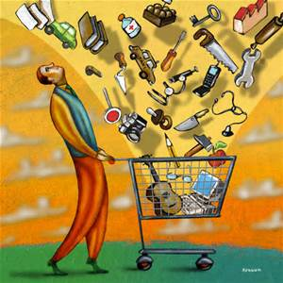 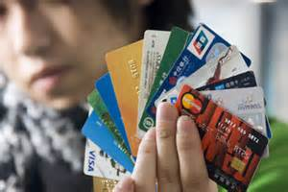

1. **domestic consumption国内消费，内需**

*Dirk Schlotbller*, （an economist at the chambers of commerce）, says **geopolitical（adj.）** tensions and **overgenerous（adj.）** government spending **commitments** should, still give German businesses reasons for **caution**； but [for now] the chambers' member firms are telling him that things are **looking up**.

一位商会的经济学家德克·史洛博乐表示，地缘政治紧张，以及过分慷慨的政府支出承诺，都是德国企业应当谨慎的原因。不过当前商会的成员公司，都纷纷告诉他一切都在好转。

1. com-merce ['kɒ-mɜ:s] n.商业；商务；贸易
2. **geo-poli-tical** [ˌdʒi:əʊ-pə'lɪ-tɪkl] **adj.地理政治学的，地缘政治（学）的**
3. **over-gene-rous** [ˌəʊvə-'dʒenə-rəs]**adj.过于慷慨的**
4. **government spending政府开支，政府支出**

————————————

1. **com-mit-ment** [kə-'mɪt-mənt] **n.承诺，许诺**；委任，委托；致力，献身；承担义务

**1.N-UNCOUNT信奉；忠诚**Commitment is a strong belief in an idea or system.

...commitment to the ideals of Bolshevism. 对布尔什维克主义理想的信奉

**2.N-COUNT承诺；责任；义务**A commitment is something which regularly takes up some of your time because of an agreement you have made or because of responsibilities that you have.

I've got a lot of commitments... 我承担了很多责任。

Work commitments forced her to uproot herself and her son from Reykjavik. 她的工作迫使她和儿子从雷克雅未克搬走。

**3.N-COUNT承诺；许诺**If you make a **commitment to** do something, you promise that you will do it.

We made a commitment to keep working together... 我们承诺继续合作。

They made a commitment to peace. 他们承诺要维护和平。

 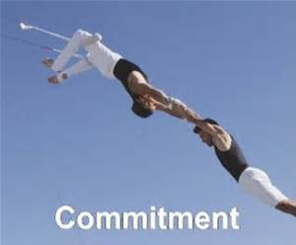

•but [for now] the chambers' member firms are telling him that things are **looking up**.

1. **look up**

**1.PHRASAL VERB（在参考书、列表等中）查检（事实或信息）**If you **look up** a fact or a piece of information, you find it out by looking in something such as a reference book or a list.

I **looked** your address **up** in the personnel file... 我在人事档案里找到了你的地址。

Many people have to look up the meaning of this word in the dictionary. 这个词的意思，很多人都要查字典才知道。

**2.PHRASAL VERB拜访，探访，看望（久未见面的人）**If you **look** someone **up**, you visit them after not having seen them for a long time.

I'll try to look him up, ask him a few questions... 我会设法**登门拜访**，问他几个问题。

She looked up some friends of bygone years. 她**去看望了**一些过去的老朋友。

**3.PHRASAL VERB改善；好转**If a situation is **looking up**, it is improving.

Things could be **looking up /** in the computer industry. 计算机行业的情况可能会**好转**。